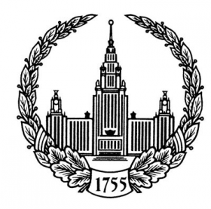
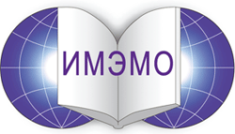

LIST OF PARTICIPANTS

Name of the Conference

Institute of World Economy and International Relations, RAS
Dec 3-5, 2010, Moscow,
(23 Profsoyuznaya St., Conference-Hall, 3rd floor)

Foreign Participants

1 | Pickering Thomas | Head of the delegation of the US National Academies, US Ambassador (ret.), Hills & Company Consulting Company
2 | Schweitzer Glenn | Director, Office for Central Europe and Eurasia, US National Academies

Russian Participants

1 | Voitolovsky Fedor | Member of RAS, Director of the Primakov Institute of World Economy and International Relations (IMEMO), RAS
2 | Myasoedov Boris | Full member of RAS, Chairman of the Interdepartmental Scientific Council on Radiochemistry under the Presidium of the RAS and the State Atomic Energy Agency Rosatom, Advisor to the Presidium of RAS

Scientific Secretary of the symposium and organizational work

1 | Shiyan Yuri | Scientific secretary of the symposium, project coordinator
2 | Davydov Alexey | PhD (Political Science), Research Fellow, Center for the Middle East Studies, IMEMO
6 | Tamazov Dmitry | Simultaneous interpreter

